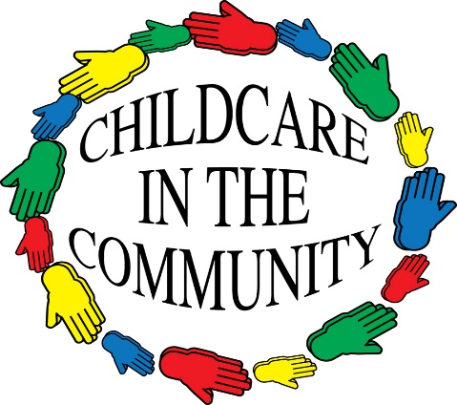

Out of School Care Handbook

Childcare in the Community
Whitehill Neighbourhood Centre
9 Hunter Road
Whitehill
Hamilton
ML3 0LH
Telephone No: 01698 476586/477498
Mobile 07747195595
Web: www.childcareinthecommunity.co.uk
Email: childcareinthecommunity@btconnect.com

Welcome

On behalf of all our staff I would like to take this opportunity to welcome you and your family to Childcare in the Community.

It is the aim of Childcare in the Community to provide a safe, stimulating environment where children will have the opportunity to play naturally and the opportunity to participate in more structured play and learning environments.

We aim to provide a quality service that parents/carers can rely on, thus allowing them to participate in training or employment.

Karen Shields
Childcare Manager

Our Staff
Karen Shields, Childcare Manager
Linda Colquhoun, Nursery Manager
Jennifer Etherson, Administrator

Whitehill OOSC
Lynn McGuiness, Service Manager
Brenda Miller, Playworker
Burnbank OOSC
Fiona Fleming, Service Manager
Susan Clelland, Playworker

Children’s play

At Childcare in the Community children’s play is freely chosen from a variety of play spaces and resources. Children determine and control the content and intent of their play.



Staff

All our staff are qualified and fully trained in child protection, first aid and REHISS.
Our staff provide a stimulating and challenging play environment where children can express their feelings in a positive way and make new friends.

Provision of Meals & Snacks

Children have the opportunity to be involved in handling, tasting and learning about different foods, discovering ways in which eating and drinking help us to grow and keep healthy.
The children plan their own healthy snack menu.
Term Time: Childcare in the Community will provide each child with a healthy snack.
Holiday Time: Children bring their own heathy packed lunch, children will have the choice of a healthy breakfast in the morning and afternoon snack.

Children Absent from Collection Point

In the event of your child not being at the collection point, Childcare in the Community staff will confirm if the child has attended school that day. The parent/carer will be contacted in the first instance and if unable to contact either parent/carer, the emergency contacts will be notified. Thereafter the child will be reported missing to the police.

Collection of Children

The person who is collecting the child must sign them out before taking them home. The service must be given a note of the names and addresses of any persons authorised to collect your child and Childcare in the Community must be given a copy of their signatures. Parents/Carers are responsible for ensuring that any alterations or updates to their emergency contact list is provided to Childcare in the Community.
If someone other than the parent/carer is collecting the child, the person collecting the child must be given a password. Passwords must be made between Parents/Carers and the out of school care manager. The person collecting the child must be over 16 years of age.
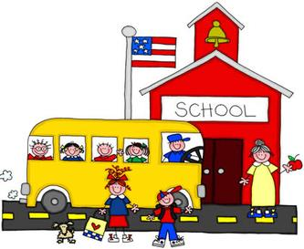

Emergency Contacts

Emergency contacts should be people who would be willing to collect and care for your child if your child is sick. They should have agreed to be emergency contacts and should have signed the appropriate registration form. If your child is sick you will be notified first. If you are unable to be contacted, the emergency contact will be notified.

Medical Conditions
The service MUST be made aware of any medical conditions that your child suffers from. Parents wishing a child to be given prescribed medicine must complete a consent form detailing the prescribed medicine.

First Aiders
All of our staff are qualified first aiders.

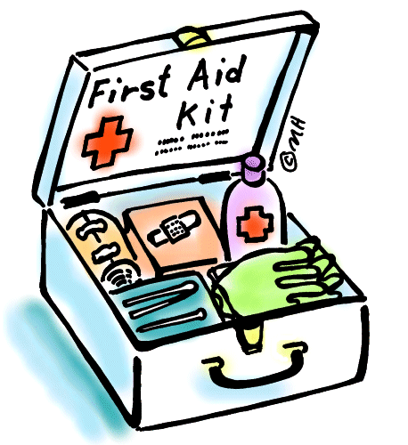

Sick Children

The out of school care is required by regulations not to admit or retain children while they are ill. This is to prevent cross infection with other children. Should a child develop symptoms of illness (rash, high temperature, vomiting, diarrhoea, etc) while at the out of school care parent/carer will be advised immediately. Children with sickness/ diarrhoea must remain off for 48 hours after the last bout.


Fundraising

To help maintain and develop the service it is important to hold regular fundraising events in which ALL parents and children will be encouraged to participate. Any fundraising ideas would be welcomed.

Consent for Photographs

Occasionally photographs taken in the childcare service are used for publicity/advertising materials. You will be asked to complete a Consent Form (attached to Registration Form) stating whether or not you agree to your child’s photograph being used in these materials.



Confidentiality

Confidentiality within the childcare facility is essential to promote a trusting relationship between staff, children, and parent/carer.
Parents can consult with staff at any time, on any issue relevant to the care of their children and any information exchanged will be dealt with in the strictest confidence.

Personal Belongings

If your child brings toys/ICT equipment to the out of school care, the organisation cannot accept responsibility for these personal belongings. We would prefer it if these remain at home.
Polices/Procedures

The out of school care has a number of policies and procedures which we adhere to. You can find a copy of these in each of our services.


School Holidays
During the school holidays children plan trips and outings giving them the opportunity to understand the world around them by exploring their own and the wider environment.
Childcare in the Community gives the children a chance to explore and appreciate the wonders of nature while having fun.


